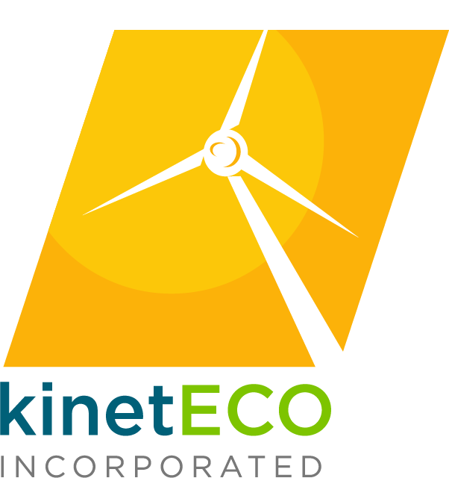KinetEco, Inc.:  
An Alternative Energy Company

# Harnessing wind and sun for an energized planet.

Test test

KinetEco, Inc. strives to maintain its position as the top manufacturer, and installer of alternative energy products and systems worldwide, while serving as a key advocate for the development and implementation of alternative energy practices at the government level, and as a leading authority on alternative energy responsible for disseminating information to the public and educational and research institutions.

# About the Company

As a planet, our energy usage is staggering, as is the environmental pollution that results. It’s obvious that traditional fossil fuel is no longer the answer, and that we must adapt to a new way of existing – one that involves the adoption of alternative renewable energy practices. KinetEco, Inc. is at the forefront of alternative energy research, design, and manufacturing – creating alternatives for home and business. From capturing energy from the sun with our K-Eco Solar Panels, to harnessing the power of wind with our various wind turbines, windmills, and windpumps, we’re continuously advancing the science of alternative energy and making it affordable and adaptable in a host of situations.

Our K-Eco Solar Panels are among the most advanced solar arrays in the industry. Combined with our K-Eco Solar Battery (chargers) and solar inverters, they form complete photovoltaic systems – that are ready to harness and store the sun’s energy.

We’ve also taken huge strides in the development of wind power alternatives, including our K-Eco Wind Machine – an industrial strength wind turbine system that can power an office building of 40 people, for 20 percent of each work day, significantly cutting down on usage of fossil fuel and creating substantial dollar savings in power consumption.

# Company Structure

*KinetEco, Inc. Administrative Headquarters (AHQ)* campus is in Downtown Los Angeles, California, at 123 KinetEco Drive in the KinetEco Tower – recently renovated to harness sun and wind power. The Tower is a full-scale alternative energy model that’s also an architectural work of art. The structure has won numerous environmental and architectural awards, including the Excellence in Environmental Aesthetics in 2010 – that provided a grant of 2.8 million dollars to help convert other Los Angeles city buildings into renewable energy partners, joined together on a solar and wind power grid.

*KinetEco, Inc. Laboratories*, along with our Research Design Team (RDT), is headquartered in Barstow California, on 125-acres of experimental wind- and solar-powered terrain. The laboratory is the heart of company research efforts, and plays host to researchers from all around the world, in an attempt to design and develop the most practical, efficient, and effective alternative energy systems and products.

*KinetEco, Inc. Manufacturing* is also in Barstow, on a neighboring 5-acre parcel and is the center manufacturing facility for the company. The plant not only produces alternative energy products, but also uses alternative energy to run the equipment and processes needed to make the products. In addition, the plant is heading toward becoming a Zero Waste Facility – reusing all plastics, metals, and chemicals required for the creation of *KinetEco* alternative energy products.

*KinetEco, Inc. Distribution* has branches in all 50 states, and in 25 countries – and is a leading supplier of alternative energy products around the world.

*KinetEco, Inc. Retail Division:* Our retails stores are in all the locations serviced by our Distribution division – and focus on selling smaller-scale systems for the home or small business.

*KinetEco, Inc. Installation Support Team:* Our professional installation technicians are stationed all around the world and are skilled in the operation and installation of all KinetEco alternative energy products. From smaller scale cabin, home, or small business systems, to massive alternative energy grid systems – we have installation technicians that are skilled in installing the systems, and troubleshooting problems, as well as performing regular maintenance.

# Executive Team

**Simon Lodine, PhD, CEO:** Dr. Simon Lodine comes to KinetEco after building his own successful alternative energy using sugar beets to power off-highway vehicles including tractors, backhoes, and other heavy farm equipment. Dr. Lodine discovered and refined his sugar beet formula while finishing his doctoral thesis at MIT. He brings an unusual mix of scientific and business- mindedness that has catapulted KinetEco into its number one position as the worldwide leader in alternative energy research and development.

**Sally Kerner, MBA, CFO:** Ms. Kerner was a Rhodes Scholar studying the international economics of alternative energy development in third world countries. Her research demonstrated that alternative energy could be harnessed in under-developed nations with better economics and consistency, than with traditional energy. Under Ms. Kerner’s astute financial management, KinetEco has broken barriers in delivering alternative energy to third-world and developing countries.

**June Su-Woo, JD, Legal Counsel:** Ms. Woo has lobbied for the *Solar and Wind Alternative Energy Commission* and served as chief counsel for the Green & Grow Solar Power initiative, that introduced solar power into rural communities all around the United States.

**Jason Hemlock, PE, Principal Design Engineer:** Mr. Hemlock previously worked for NASA, where over a two decades, he helped pioneer solar panel technology for space shuttle missions. His pursuit of alternative energy for space exploration earned him and his design team at NASA a Nobel Prize nomination. Mr. Hemlock is responsible for establishing design standards and quality control measures for the development of all KinetEco, Inc. products, from residential systems, to massive industrial alternative power grids.

**Partial Product Listing**

K-Eco Solar Panels

* 6-Watt 12- Volt
* 200-Watt
* 250-Watt
* 300-Watt

K-Eco Wind Machine

K-Eco Wind Tunnel

K-Eco DIY Grid

K-Eco Light Bright outdoor night-lights

K-Eco Personal Solar Charger (for cell phones and laptops)